# Python·

1. c=3+4j;  
print(c+c)  
print(c**2)  
print(c.real)  
print(c.imag)  
print(3+4j.imag)  
print(c.conjugate())  
print(abs(c))

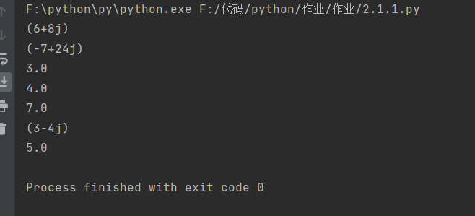

2.

x_list = [1, 2, 3]  
x_tuple = (1, 2, 3)  
x_dict = {'a' : 97, 'b' : 98, 'c' : 99}  
x_set = {1, 2, 3}  
print(x_list[1])  
print(x_tuple[1])  
print(x_dict['c'])  
print(len(x_list))  
print(x_tuple.index(2))  
for key ,value in x_dict.items():  
 if value==98:  
 print(key)  
print(max(x_set))

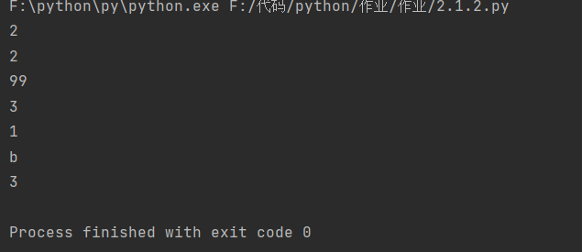

3.

text = '''Beautiful is better than ugly.  
Explicit is better than implicit.  
Simple is better than complex.  
Complex is better than complicated.  
Flat is better than nested.  
Sparse is better than dense.  
Readability counts.'''  
print(len(text))  
print(text.count('is'))  
print('beautiful' in text)  
print('='*20)  
print('Good'+'Morning')  
import matplotlib.pyplot as plt

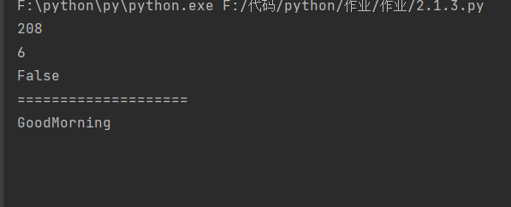

4.

from typing import List  
import collections  
  
print(3+5)  
print(3.4+4.5)  
print((3+4j)+(5+6j))  
print('abc'+'def')  
print([1,2]+[3,4])  
print((1,2)+(3,))  
  
  
print(7.9-4.5)  
print(5-3)  
num=3  
print(-num)  
print(--num)  
print(-(-num))  
print({1,2,3}-{3,4,5})  
print({3,4,5}-{1,2,3})  
  
print(33333*55555)  
print((3+4j)*(5+6j))  
print('重要的事情说三遍!'*3)  
print([0]*5)  
print((0,)*3)  
  
print(17/4)  
print(17//4)  
print((-17)/4)  
print((-17)//4)  
  
print(365%7)  
print(365%2)  
print('%c,%c,%c'%(65,97,48))  
  
  
print(2**4)  
print(3**3**3)  
print(3**(3**3))  
print(9**0.5)  
print((-1)**0.5)

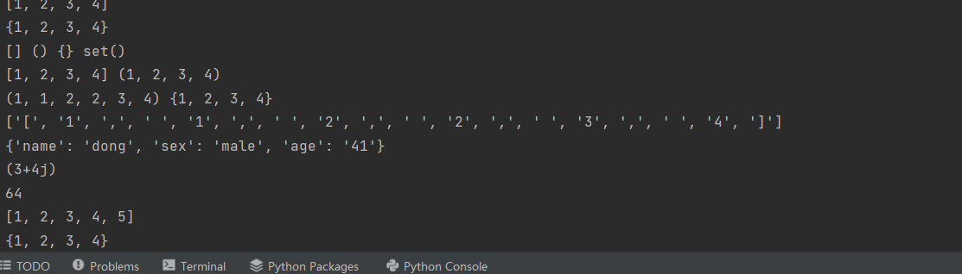

5.

for i in range(1,6,2):  
 print('1-6之间的奇数：'+str(i))  
  
coures=['节','星期一','星期二','星期三','星期四','星期五',  
 '1','高等数学','计算机基础计','管理学原理','思想政治','Python编程',  
 '2','高等数学','计算机基础计','管理学原理','思想政治','Python编程',  
 '3','电子商务','离散数学','计算机基础计','大学英语','离散数学',  
 '4','电子商务','离散数学','计算机基础计','大学英语','离散数学',  
 '5','Python编程','电子商务','高等数学','专业实践','大学英语',  
 '6','Python编程','电子商务','高等数学','专业实践','大学英语']  
for i in range(0,42,6):  
 for j in range(0,6):  
 print(coures[i+j]+"\t",end='')  
 print("\n")

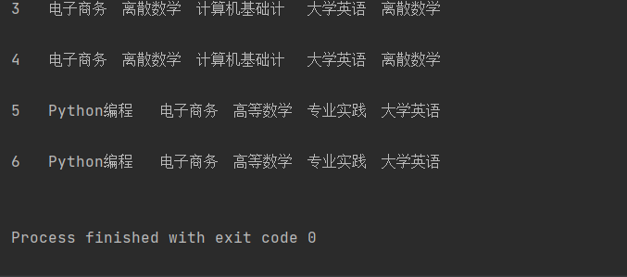

6.

vector1= eval (input('请输入一个包含若干整数的向量'))  
vector2= eval (input('请输入一个包含若干整数等长的向量'))  
print(sum([num1*num2 for num1,num2 in zip( vector1,vector2)]))  
  
data=eval(input('请输入一个包含若干整数的列表：'))  
m = max(data)  
print(m)  
print([index for index,value in enumerate(data) if value==m ])

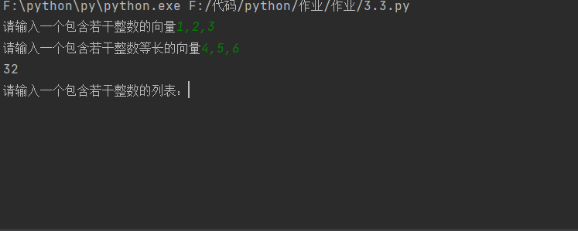

7.

from string import digits  
from random import choice  
  
z=''.join(choice(digits) for i in range(1000))  
result={}  
for ch in z:  
 result[ch] = result.get(ch,0)+1  
for digit,fre in sorted(result.items()):  
 print(digit,fre,sep=':')  
  
  
text = input('请输入一个字符串')  
result= ''.join(sorted(set(text),key=lambda ch:text.index(ch)))  
print(result)  
  
A=eval(input('请输入一个集合'))  
B=eval(input('请输入一个集合'))  
print('并集：',A|B)  
print('交集',A&B)  
print('对称差集',A^B)  
print('差集A-B',A-B)  
print('差集B-A',B-A)



8.

text=input('请输入一个包含空格的字符')  
print(''.join(text.split()))  
  
text=input('请输入一个字符串')  
table=''.maketrans('aeoiu','AEOIU')  
print(text.translate(table))

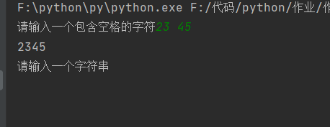

9.

import matplotlib.pyplot as plt  
month = list(range(1,13))  
money = [5.2,2.7,5.8,7.3,9.2,18.7,15.6,20.5,18.0,7.8,6.9]  
for x,y in zip(month,money) :  
 color='#%02x'%int( y*10)+'6666'  
 plt.bar(x,y,color=color,hatch='*',width=0.6,edgecolor='b',linestyle='--',linewidth=1.5)  
  
 plt.text(x-0.3,y+0.2,'%.1f'%y)  
plt.xlabel('月份',fontproperties='simhei')  
plt.ylabel('营业额（万元）',fontproperties='simhei',fontsize=14)  
plt.xticks(month)  
xzuo=list(range(0,22))  
plt.ylim(0,22)  
plt.show()

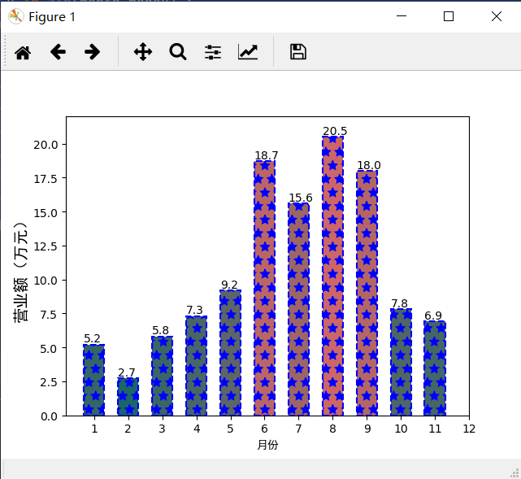

10.

import math  
print(math.factorial(32))  
print(0.4-0.3==0.1)  
print(math.isclose(0.4-0.3,0.1))  
num=7  
squreRoot=num**0.5  
print(squreRoot**2==num)  
print(math.isclose(squreRoot**2,num))

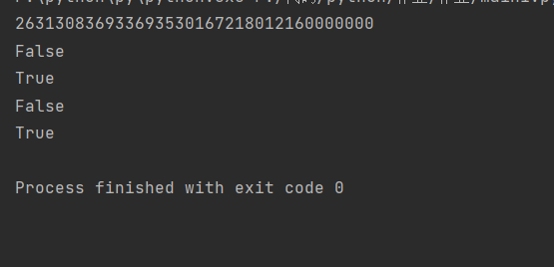

11.

data=[2**i for i in range(64)]  
sum=0;  
for i in range(64):  
 sum=data[i]+sum  
print(data)  
print(sum)  
  
b = eval(input('请输入一个包含若干整数的列表：'))  
a=[]  
for i in b:  
 if(i%2==1):  
 a.append(i)  
print(a)

